PHASE VII: Advanced Programming & Auditing

Object | Purpose
HOLIDAYS table | Store restricted dates
AUDIT_LOG table | Track actions
Log function | Record events
Restriction function | Validate rules
Triggers | Enforce rules
Test queries | Proof

Holiday Management Table – Description
This table stores official public holidays used by the system to enforce business rules.
It allows the database to automatically block designers from inserting, updating, or deleting records on public holidays within the upcoming month.

Stores public holidays so the system can restrict designers’ database actions on those dates.
Code:

CREATE TABLE holidays (
holiday_id NUMBER GENERATED BY DEFAULT AS IDENTITY
CONSTRAINT pk_holidays PRIMARY KEY,
holiday_date DATE
CONSTRAINT uq_holiday_date UNIQUE
CONSTRAINT nn_holiday_date NOT NULL,
description VARCHAR2(100)
);

SAMPLE:
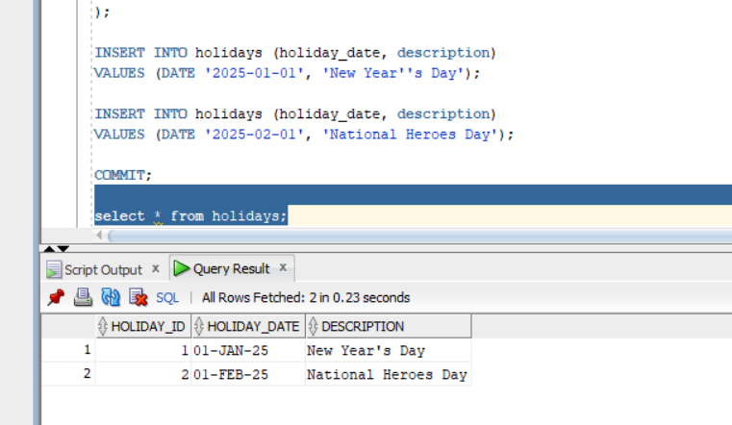

AUDIT LOG TABLE
This table records all designer attempts to INSERT, UPDATE, or DELETE data in the system.
It captures who performed the action, what action was attempted, when it occurred, and whether the action was allowed or denied for auditing and security purposes.
Code:
CREATE TABLE audit_log (
audit_id NUMBER GENERATED BY DEFAULT AS IDENTITY
CONSTRAINT pk_audit_log PRIMARY KEY,
username VARCHAR2(50) NOT NULL,
action_type VARCHAR2(10) NOT NULL,
table_name VARCHAR2(30) NOT NULL,
action_date DATE DEFAULT SYSDATE NOT NULL,
action_status VARCHAR2(10) NOT NULL,
remarks VARCHAR2(200)
);
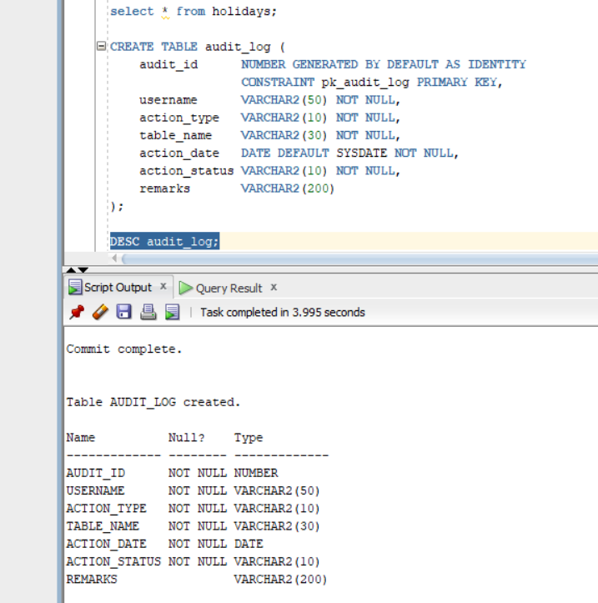

Audit Logging Function
This function records every INSERT, UPDATE, or DELETE attempt made by a designer into the audit log table.
It centralizes auditing logic so all triggers can log actions consistently and reliably.
Code:
CREATE OR REPLACE FUNCTION log_audit_action (
p_action_type IN VARCHAR2,
p_table_name IN VARCHAR2,
p_action_status IN VARCHAR2,
p_remarks IN VARCHAR2
)
RETURN NUMBER
AS
BEGIN
INSERT INTO audit_log (
username,
action_type,
table_name,
action_status,
remarks
)
VALUES (
USER,
p_action_type,
p_table_name,
p_action_status,
p_remarks
);

RETURN 1; -- success

EXCEPTION
WHEN OTHERS THEN
RETURN 0; -- failure
END;
/
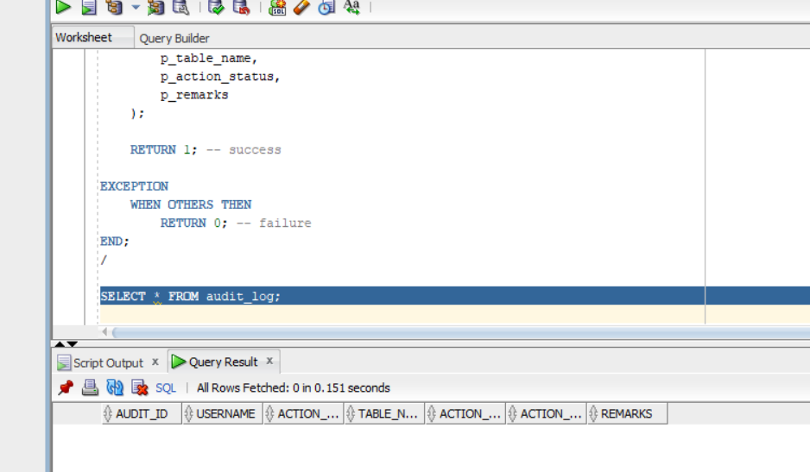

RESTRICTION CHECK FUNCTION

This function checks whether a designer is allowed to modify data based on the current date.
It blocks database actions on weekdays (Monday–Friday) and on public holidays stored in the holidays table.

CREATE OR REPLACE FUNCTION is_action_allowed
RETURN BOOLEAN
AS
v_day_name VARCHAR2(10);
v_holiday_count NUMBER;
BEGIN
-- Get current day name (MON, TUE, etc.)
v_day_name := TO_CHAR(SYSDATE, 'DY', 'NLS_DATE_LANGUAGE=ENGLISH');

-- Check if today is a weekday
IF v_day_name IN ('MON', 'TUE', 'WED', 'THU', 'FRI') THEN
RETURN FALSE;
END IF;

-- Check if today is a public holiday
SELECT COUNT(*)
INTO v_holiday_count
FROM holidays
WHERE holiday_date = TRUNC(SYSDATE);

IF v_holiday_count > 0 THEN
RETURN FALSE;
END IF;

-- If weekend and not a holiday, allow action
RETURN TRUE;

EXCEPTION
WHEN OTHERS THEN
RETURN FALSE;
END;
/
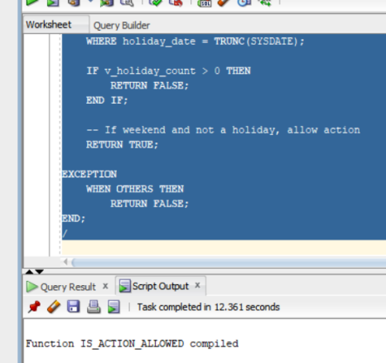

COMPOUND TRIGGER
This trigger enforces business rules by preventing designers from inserting, updating, or deleting data on weekdays and public holidays.
It also records all allowed and denied actions in the audit log table for accountability and security

Code:
CREATE OR REPLACE TRIGGER trg_projects_restrict_audit
FOR INSERT OR UPDATE OR DELETE ON Projects
COMPOUND TRIGGER

v_action_allowed BOOLEAN;
v_action_type VARCHAR2(10);
v_log_result NUMBER;

BEFORE STATEMENT IS
BEGIN
-- Determine action type
IF INSERTING THEN
v_action_type := 'INSERT';
ELSIF UPDATING THEN
v_action_type := 'UPDATE';
ELSIF DELETING THEN
v_action_type := 'DELETE';
END IF;

-- Check if action is allowed
v_action_allowed := is_action_allowed;

IF NOT v_action_allowed THEN
-- Log denied action (FUNCTION call)
v_log_result := log_audit_action(
v_action_type,
'PROJECTS',
'DENIED',
'Action blocked: weekday or public holiday'
);

-- Block the action
RAISE_APPLICATION_ERROR(
-20001,
'Action denied: Designers cannot modify data on weekdays or public holidays.'
);
END IF;
END BEFORE STATEMENT;

AFTER STATEMENT IS
BEGIN
-- Log allowed action (FUNCTION call)
v_log_result := log_audit_action(
v_action_type,
'PROJECTS',
'ALLOWED',
'Action permitted'
);
END AFTER STATEMENT;

END trg_projects_restrict_audit;
/

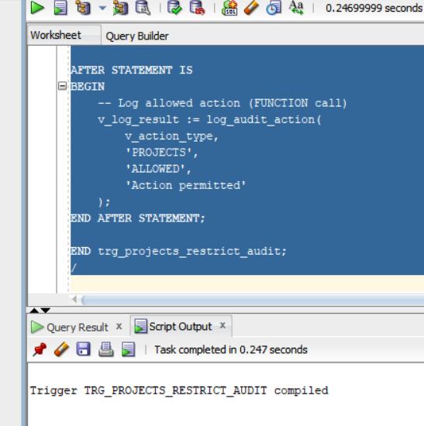

TESTING THE TRIGGER

Code:
INSERT INTO Projects (title, project_type, start_date, budget, status, client_id)
VALUES ('Blocked Project', 'Architecture', SYSDATE, 500000, 'Pending', 1);

